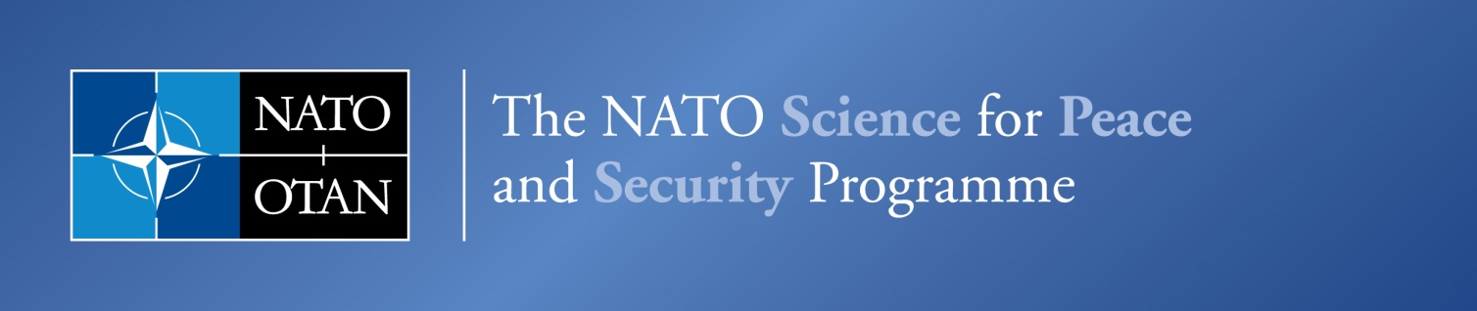
NATO Emerging Security Challenges Division

Women, Peace & Security
15th Anniversary of UNSCR 1325

29 October, 2015

DRAFT PROGRAMME

09:00 | Registration of participants
09:25 | SESSION I – Welcome Address  Ambassador Sorin Ducaru, Assistant Secretary General, Emerging Security Challenges Division  Ambassador Marriёt Schuurman, NATO Secretary General’s Special Representative for Women, Peace & Security  Moderator: Michael Gaul, Senior Advisor Projects and Strategy, Emerging Security Challenges Division, NATO
09:45 | SESSION II – ‘Good practice in handling gender-related complaints in armed forces: Overview of the project’s findings and recommendations’  Introduced by Ambassador Christian Meuwly, Ambassador of Switzerland to the Kingdom of Belgium and Head of the Swiss Mission to NATO  Ms Megan Bastick  Gender and Security Fellow, Geneva Centre for the Democratic Control of Armed Forces  - Presentation of project findings & recommendations  ---------------------------------------------------------  Panel Discussion  Mr Roald Linaker  Parliamentary Ombudsman for the Norwegian Armed Forces  Ms Jill Loftus  Director of the Department of the Navy Sexual Assault Prevention Office , United States  Lt Col Dominique Peeters  Complaints Manager, Belgian Defence Forces  Ms Nicola Williams  Service Complaints Commissioner for the Armed Forces, United Kingdom  Moderator: Dr Hans Born, Senior Fellow, Geneva Centre for the Democratic Control of Armed Forces  Closing Remarks by Ambassador Knut Hauge, Ambassador of Norway to NATO
11:00 | SESSION III – ‘NATO Scorecard’: Indicators for the implementation of UNSCR 1325  Introduction by Ambassador Douglas Lute, Ambassador of the United States Mission to NATO (TBC)  Dr Chantal de Jonge Oudraat, President of WIIS Global and Senior Advisor to the Center for Gender and Peace-building of the U.S. Institute of Peace  Ms. Sonja Stojanović Gajić, Director, Belgrade Center for Security Policy  - Presentation of findings & recommendations  ---------------------------------------------------------  Roundtable discussion with the audience and:  Mr. Joseph Hoenen  Civil Advisor to the 1st German/Netherlands Corps  Ms. Charlotte Isaksson  Gender Advisor to Allied Command Operations, NATO/SHAPE  Ms. Virpi Levomaa  Course Director and Instructor, Nordic Center for Gender in Military Operations  Moderators:  Col. Carolyn Washington (ret), Senior Fellow at WIIS Global  Closing Remarks by Ambassador Miomir Udovički, Ambassador of Serbia to NATO
12:30 | Drinks & Food Reception

